**ResourcePacks Lab**

**SCENARIO:** **Manuel, an enthusiastic gamer, recently installed popular Minecraft resource packs on his new computer after classmates shared download links with him. Soon after, he noticed system slowdowns, unexpected pop-ups, and malfunctioning applications. You have been asked to investigate how a suspicious file infiltrated the machine, whether it created hidden persistence mechanisms, and assess any impact on personal data or overall system stability.**

Initial Access

Q1

The threat actor has set up a video to provide the link that hosts the filefix command file. What is the YouTube channel display name of the threat actor?

Start by checking user browser history and you will be able to see this

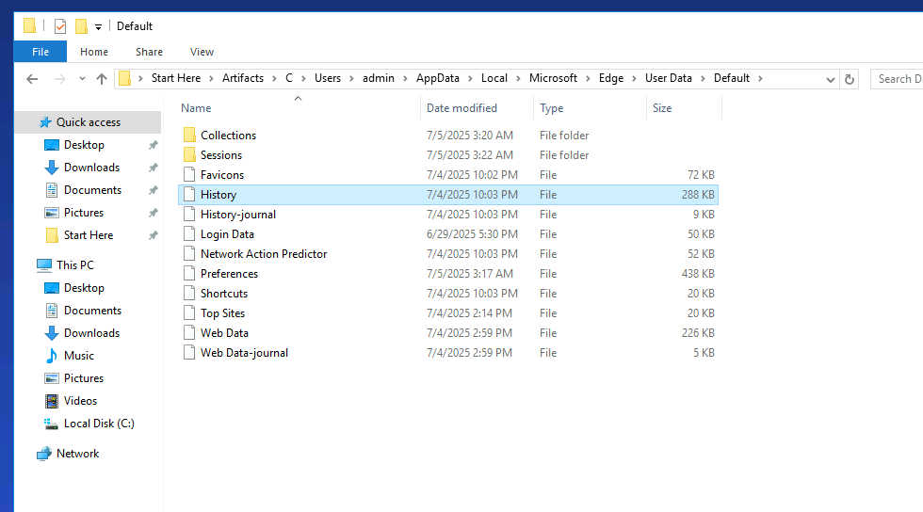

Going to the youtube link

<https://www.youtube.com/watch?v=oGrKXom1S7E>

Note:I will keep the video content as a surprise

Q2

Provide the full url that was used to deliver a malicious command to the victim.

We already have the short url link now we need to look for the full url

<http://ultimatempacks.at/autoinstall.html>

Execution

Q1

When did the user execute the malicious command?

The user started the download at least after this time

2025-07-04 22:03:30

Using

EvtxECmd.exe -d "C:\Users\Administrator\Desktop\Start Here\Artifacts\C\Windows\System32\winevt\Logs" --csv "C:\Users\Administrator\Desktop\Start Here\Artifacts\Evtx_Output"

I was able to found this

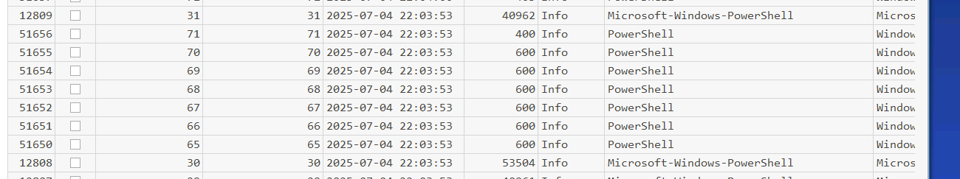

Further investigation confirmed it

Q2

Provide the full fake file path that appeared to trick the user into executing the command?

From previous log that we found

C:\manuel\AppData\Roaming\.minecraft\resourcespack\Hyper-Realistic-1.7.2.zip

Q3

Provide the name of the script that was executed by the user with this command?

In the same powershell command

ultimatetexture.jpg

Q4

The script fetched an executable file from the C2 server and executed it from another built-in user folder. Provide the full path of this file.

Top of Form

Looking a little I found this

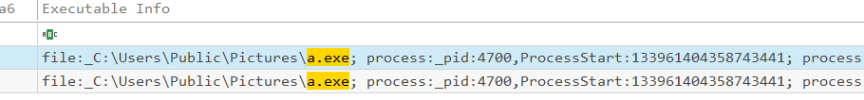

This cant be a normal exe file found in pictures

C:\USERS\PUBLIC\PICTURES\A.

Discovery

Q1

The threat actor conducted some enumeration on the system once it gained initial access; how many times was `net.exe`Used by the threat actor during the discovery phase?

Also found a third one later on

Privilege Escalation

Q1

The threat actor dropped a `.cmd` script to bypass the user control mechanism to gain a high-integrity access token; what is the name of that script?

By using pecmd output I looked for .cmd and found

uacbypass.cmd

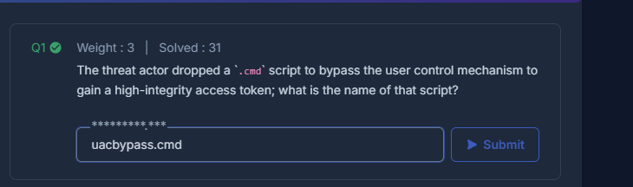

Q2

To understand the behavior of the threat actor, decode the Base64 string and find out how many seconds was set to delay before proceeding with the cleanup?

Top of Form

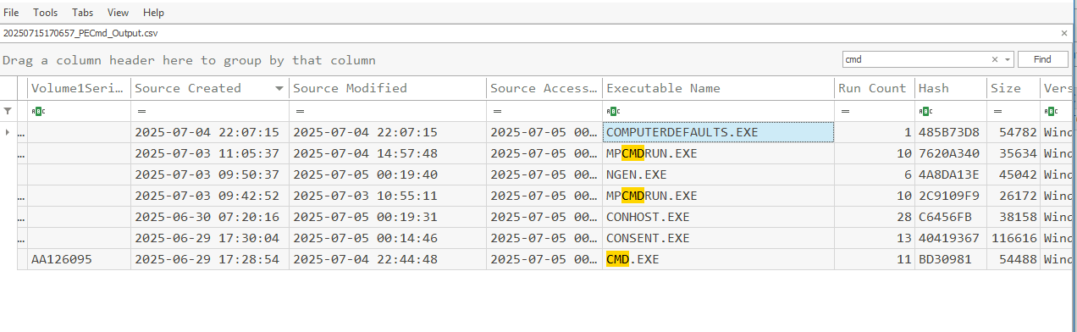Top of Form

COMPUTERDEFAULTS.EXE

Persistence

Q1

The threat actor stored a one-liner command in the Windows built-in repository. List the name of **the class** and **property used for this action**.

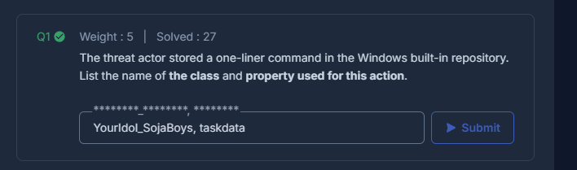

YourIdol_SojaBoys, taskData

Q2

To understand the behavior of the threat actor, decode the Base64 string and find out how many seconds was set to delay before proceeding with the cleanup?

Using evtxcmd output

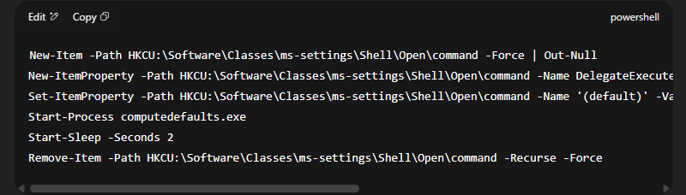

Q3

The threat actor created a backdoor user with a name that mimics the actual user on this machine. When was that backdoor created?

Using evtxcmd output again I searched for event id 4720 that represented account creation and found this

Privilege Escalation(again)

Q1

The threat actor dropped another script to add special privileges to the newly created backdoor account without adding it to the Administrators group. What is the name of this script?

Q2

Which privilege was assigned to the backdoor user?

Defense Evasion

Q15

To import a security template file, the threat actor needs to export the config file to an `.inf` file, and a `.sdb` file will be created during import. List the file names of both files.

So I first found the .inf script here

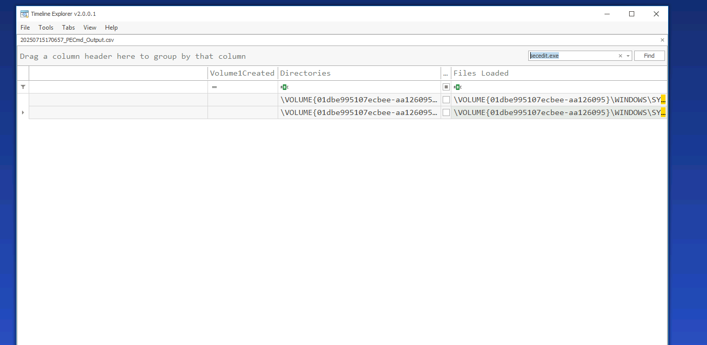

Secedit is the one that Is used to import a security template in windows

But I couldn’t find the .sdb file so I tried to load the $Extended/$J via

MFTECmd.exe -f "C:\Users\Administrator\Desktop\Start Here\Artifacts\C\$Extend\$UsnJrnl\$J" --csv "C:\Users\Administrator\Desktop\Start Here\Artifacts\C\MFTE_USN_Output.csv" 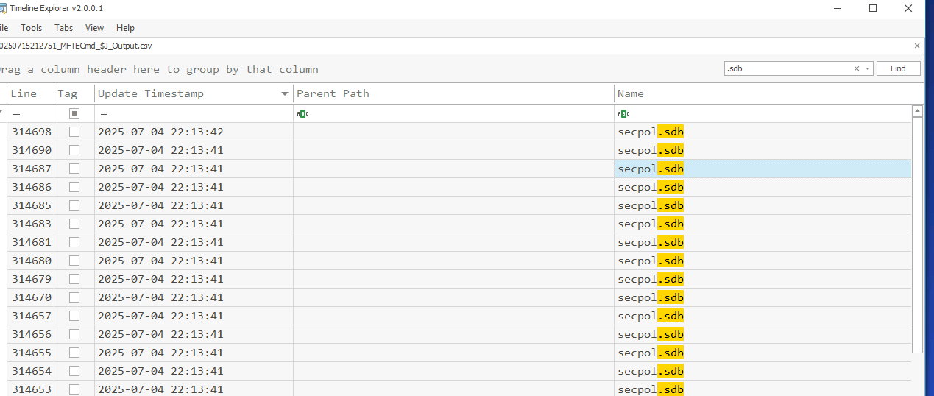

And found it

Defense Evasion

Q15

To import a security template file, the threat actor needs to export the config file to an `.inf` file, and a `.sdb` file will be created during import. List the file names of both files.

With pecmd output I tried to search for powershell command and found ibackdoor.ps1

Q16

It appears that Windows Defender has detected the malicious executable and taken some measures against it. Please list the process ID (PID) of the two processes that were detected by Windows Defender.

Using evtxcmd output

